**GLA Clean-Up Weekend Helps Eliminate The Clutter**

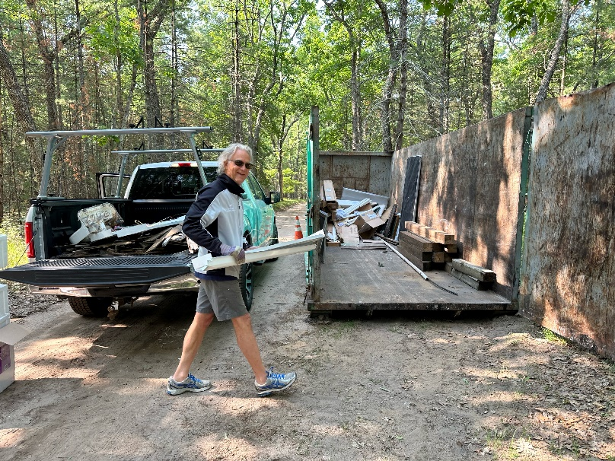

GLA Member Brian Post was one of first to use the dumpster during Clean-Up Weekend. The dumpster was filled to capacity a day later.

Gifford Lake Association (GLA) members took full advantage of Clean-Up Weekend, discarding everything from a paddleboat, sink, toilet and mattresses.

The 40-yard dumpster was put in place at the corner of Ranger and the Rebecca Rd. two-track on Thursday, June 8.  One problem after delivery: The rear gate of the dumpster wouldn’t open. Dave Van Dyk and his trusty crowbar easily solved the problem. The dumpster was filled by Saturday afternoon.

The GLA paid for the dumpster as part of its mission to provide additional benefits through last year’s due increase.

“Looks like a few people used the GLA dumpster this weekend,” said GLA member Steve Graber. “Great job folks and thanks again to the association and all participated.”

The filled dumpster awaits pick up on Monday.